Pet Face Verification and Identification

Abstract

In this project, we propose to use deep learning convolutional neural networks to detect, verify, and identify individual pet faces in digital images. We describe a moderately

sized data set of pet images sourced from online pet adoption profiles. We plan on training YOLOv3 to detect pet faces and both self-built and transferred CNN models for verification and identification. We will use confusion matrix and ROC scores to evaluate the model performance on generated pairs of pet faces.

Introduction

Deep learning and machine learning approaches have yielded impressive achievements in human face recognition and verification. There has been far less research into applying machine learning and deep learning to individual animal recognition.

There are approximately 76.8 million dogs and 58.4 million cats living as companion animals in households in the United States alone. Many of these pets are microchipped by their owners to identify the pets if the pets run away. This procedure costs around forty-five US dollars, which includes registration in a database. In contrast, a digital image-based pet registry would be less costly and more convenient to operate, thereby lowering the barrier to registering a pet.

Project Goal

Every year, there are thousands of pets are lost in the U.S. One solution for that is to microchip for their pets. However, as mentioned above, the procedure of microchipping for pets identification is costly, and if we can establish a pet’s face recognition system, it would largely reduce the cost. Therefore, the project aims to utilize image data and apply machine learning and deep learning models to build up a third-party platform for pets identification and recognition and help people find their lost pets.

Data Description

Our dataset is from PetFinder.com [[Pet's data](https://www.kaggle.com/c/petfinder-adoption-prediction/data?select=train_images)]. In the dataset, we have image data for pets as well as text data involving breed_labels, color_labels, and state_labels and pet’s description (profile write-up for this pet). There are more than 58200 images in total, and the size of the whole dataset is more than 2.3 G. For a given pet, our data involves different posture and condition for this pet. Here are some samples of our image dataset.

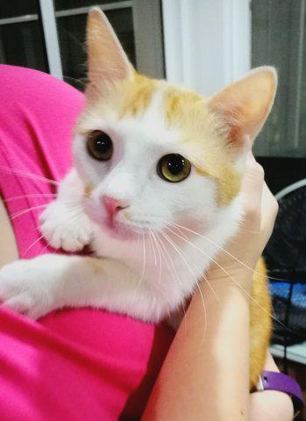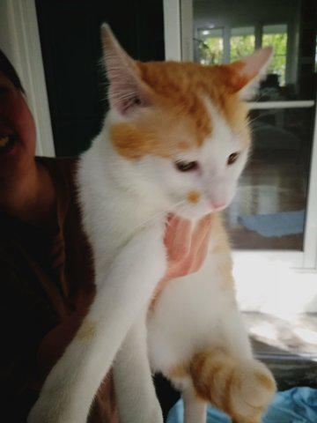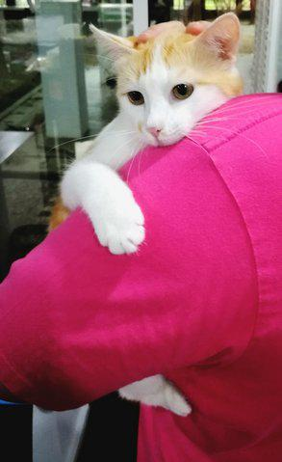

Proposed Methods

**Baseline Model**

* Traditional machine learning (although we can use a convolutional layer with pooling for feature extraction)
* Adding Text Features (involving breed labels, color labels)

**Advanced Model**

* Adaboost and Artificial Neural Network [[ANN for face recognition](http://downloads.hindawi.com/archive/2011/673016.pdf)]
* Traditional Convolutional Neural Network [[CNN for Face Recognition](https://github.com/GreamDesu/Convolutional-Neural-Network-Face-recognition/blob/master/face-recognition.ipynb)] [[Keras CNN](https://github.com/sanyuktakate/Real-Time-Face-Recognition-using-Convolutional-Neural-Network/blob/master/Project_version1/CNN_model.py)]
* Resnet [[Keras -Resnet](https://github.com/raghakot/keras-resnet/blob/master/resnet.py)] [[Resnet Step by Step Pytorch](http://d2l.ai/chapter_convolutional-modern/resnet.html)]
* Transfer Learning Model
  + Inception-ResNet-V2 and finally to EfficientNetB2 [[Stanford Deep Learning project](http://cs230.stanford.edu/projects_fall_2019/reports/26251543.pdf)]
  + YOLOv3 [[Keras - YOLO 3](https://github.com/qqwweee/keras-yolo3/)]

Proposed Evaluation Metrics

In the evaluation stage, we will create pairs of pet images with an equal likelihood to be either the same or different pets. Proposed evaluation metrics include overall accuracy, confusion matrix, and ROC curve.

Potential Constraints and Limitations

* Computation Problem
  + Since the size of this dataset is large, if we would like to train the model by ourselves, we might need to use Cloud Computing and GPU.
  + Noise of the data
    - In one image, sometimes there are two or three pets.
    - Sometimes it might be hard to distinguish the pets with some specific backgrounds.

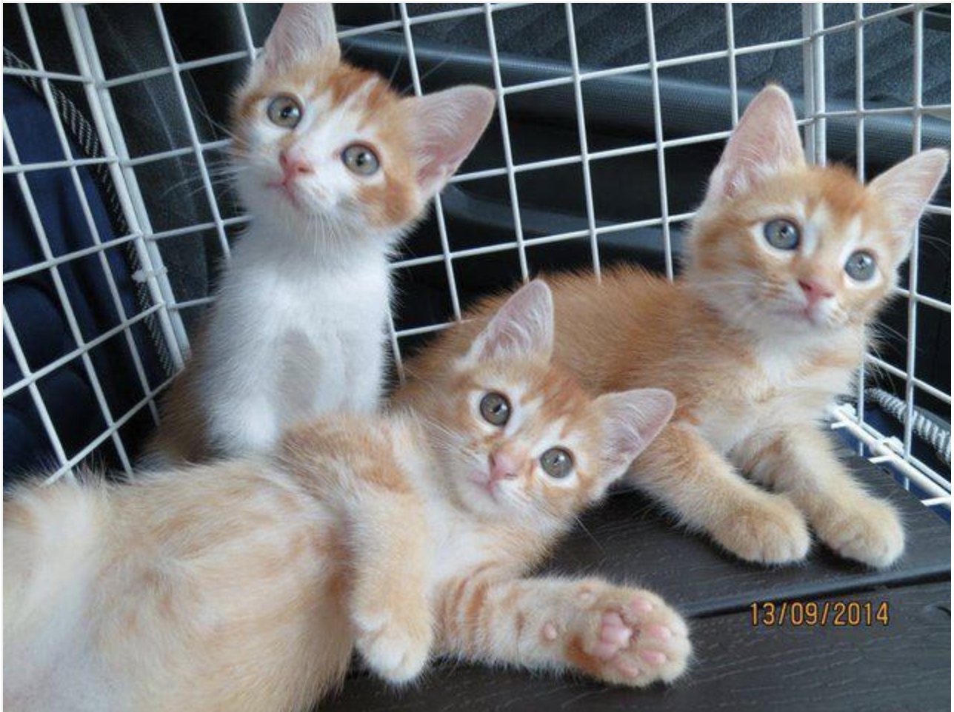

Figure 1. Three pets in one picture

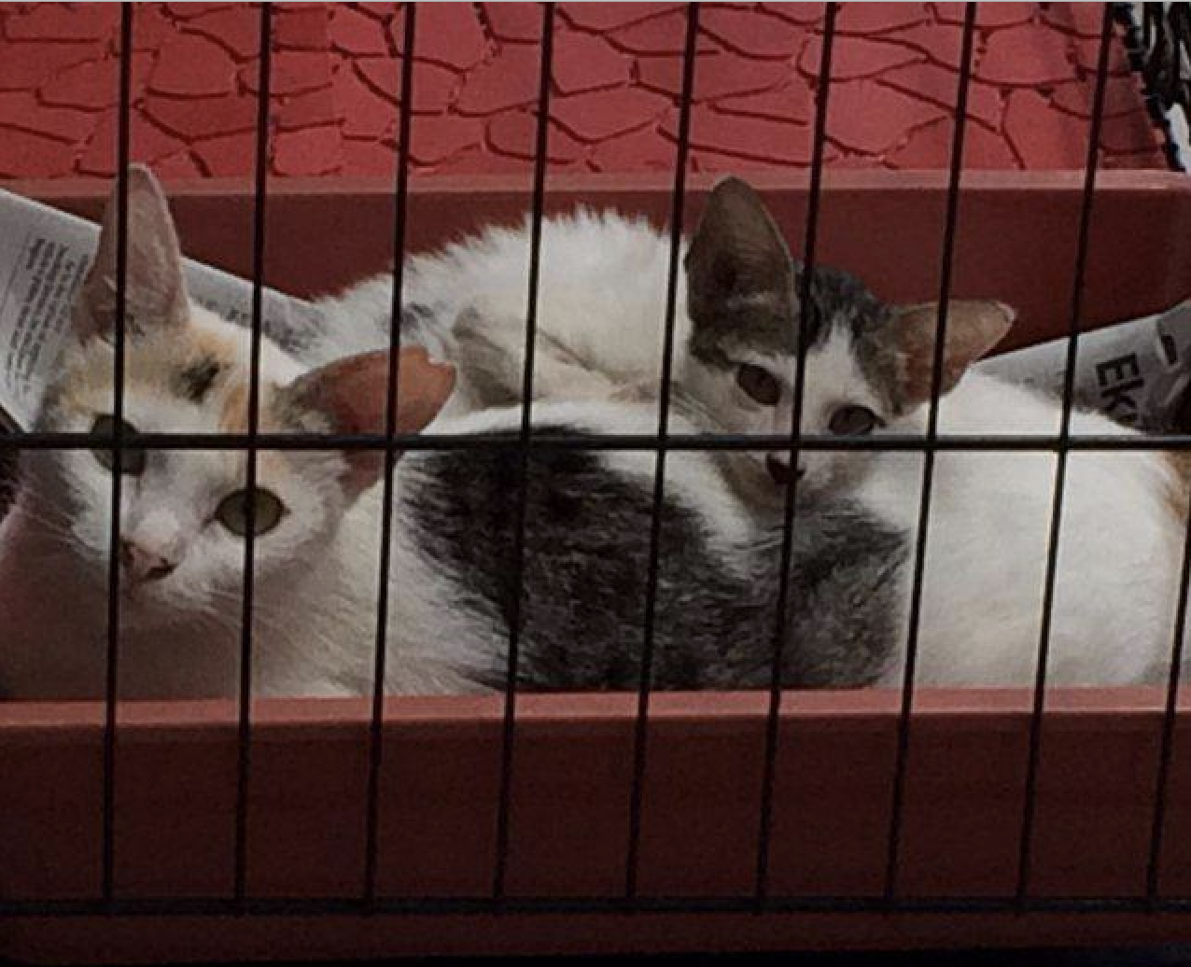

Figure 2: Background that hard to be distinguished